Level 14 -> Level 15

The goal of this level is to submit the password of the current level to **port 30000 on localhost** and get the password to the next level.

Firstly we will get the password of the current level by using the command **cat /etc/bandit_pass/bandit14**

We can use the command as **echo password_of_current_level | nc localhost 30000** to get the password of next level.

**echo** command in linux is used to display line of text/string that are passed as an argument.

**nc** is networking utility with functionality similar to cat **command** but for network. It is a general purpose CLI tool for reading, writing, redirecting data across a network.

**nc localhost port_no** is used to connect to that particular port no.

So, on clubbing these commands, echo will display the password of current level then nc will read that password and then it will make connection with the port number 30000.

This is how we will get password to the next level.

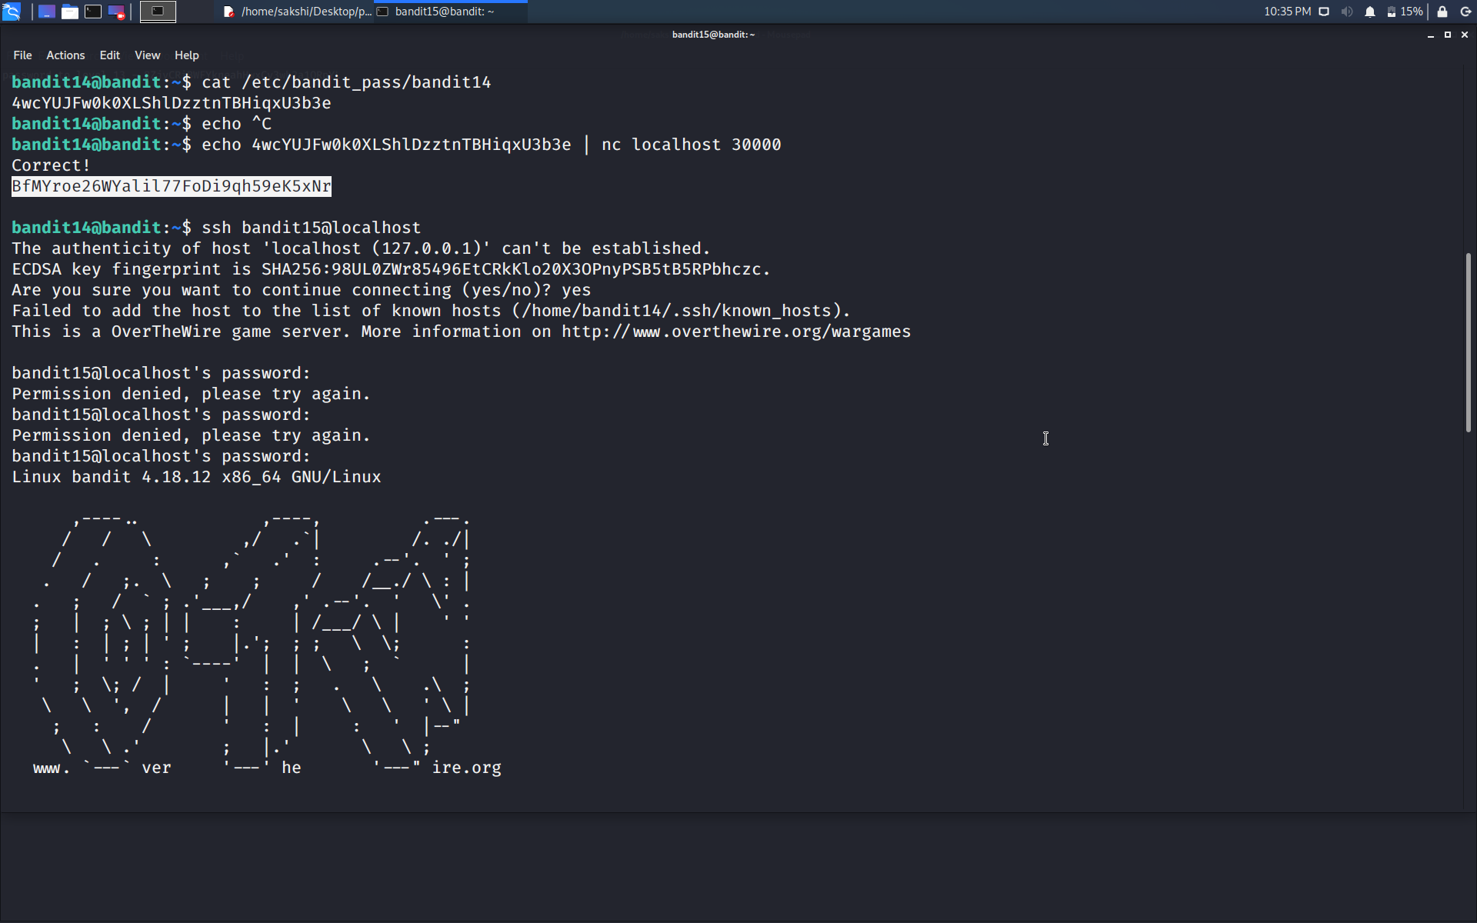

Use the command **ssh bandit15@localhost** to connect to the level 15.

Enter the password and hit enter.

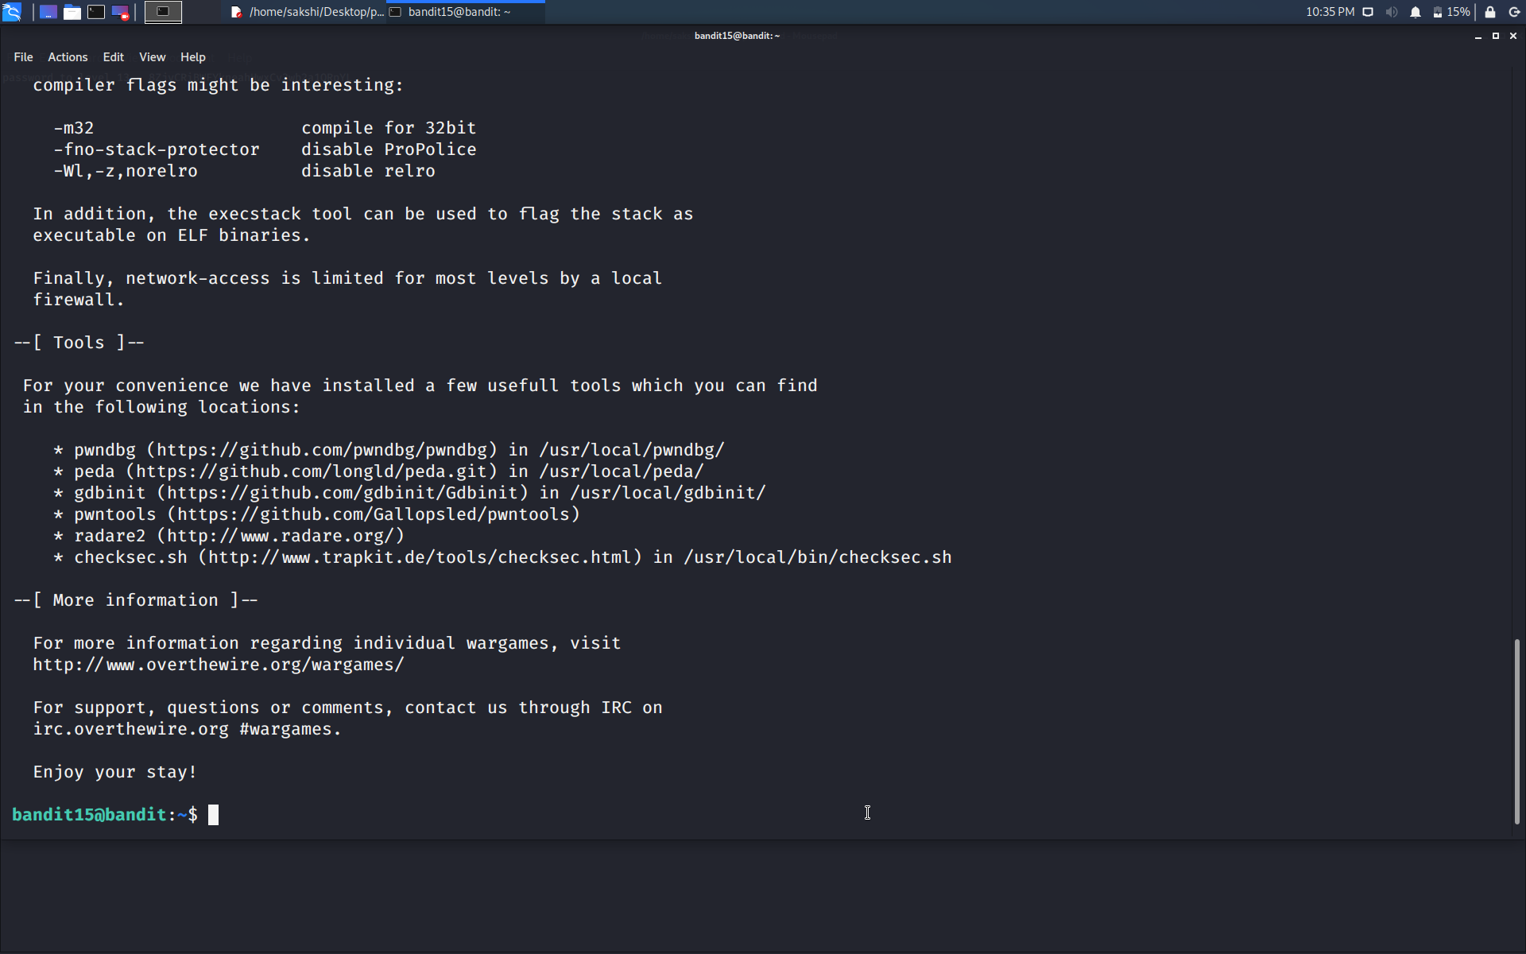

Successfully passed level 15.…